**3. Maven**

1. Why do we need a build tool like maven?

Maven likes tools help manage dependencies, build and test automation, and project structure. Maven is a build automation tool that focuses on project management and dependency management.

1. Install maven

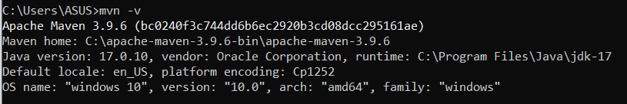

1. Display output of maven version
2. What is the pom.xml file?

pom.xml file contains information of project and configuration information for the maven to build the project such as mainly dependencies, build directory, source directory.

1. Explain these tags found in pom.xml files?

| groupId | It specifies the id of the project group |
| --- | --- |
| artifactId | Specifies the id of the project |
| version | Version of the artifact under given group |
| packaging | Packaging type |
| dependencies | Dependencies for this project |
| dependency | Defines a dependency used inside dependencies |
| properties | Included java version, maven compiler source, target |

1. Create a method which accept an integer as parameter and returns the square of it
2. Add junit (v5) dependency
3. Add a unit test to test the method

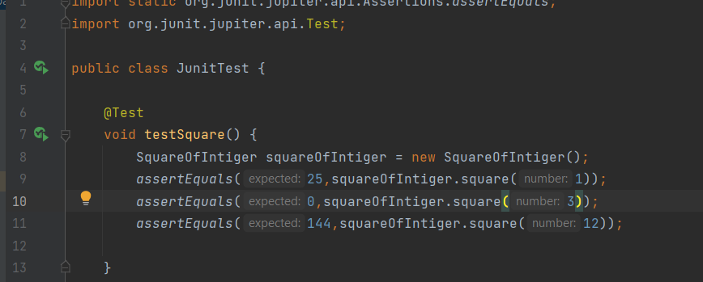

1. Run unit tests with maven. What is the command you used?

Maven test

1. Create a Student class with following attributes and add getters/setters

* id: int
* name: String
* age: int
* subjects: List<String>

1. In your main method create and student object and set these values

id: 1

name: “john”

age: 20

subjects: [“Maths”, “English”, “History”]

1. Then print these student values using getters (e.g: s.getName())

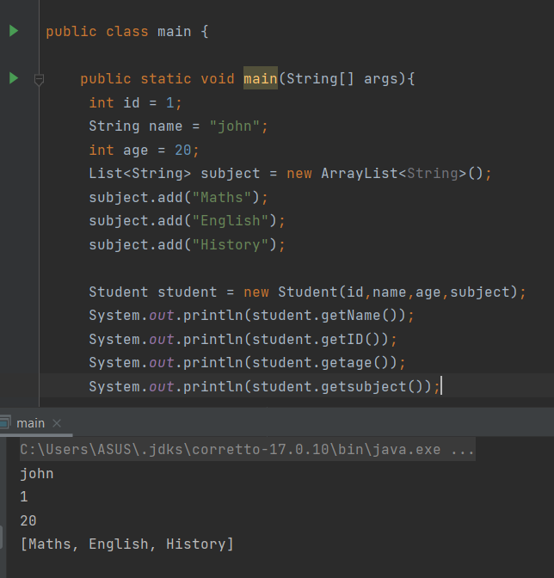

1. Add lombok dependency and remove getter/setter methods from Student class

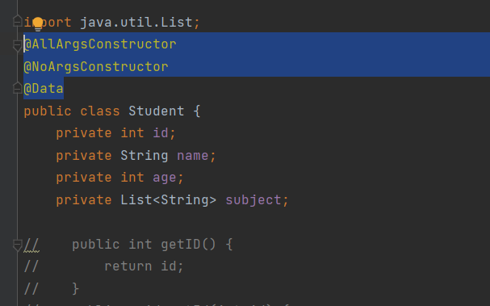

1. Explain the usage of these commands

| mvn clean | Cleans the maven project by deleting the target directory |
| --- | --- |
| mvn install | Build the maveen project and install the package files to local repository |
| mvn package | Build the maven project and creat JAR files |

1. Explain 3 types of maven repositories

Lacal Repository - located in local system. We can change location. We run the maven command then create this one

Central Repository - located on the web it has been created by the apache maven community itself. Include lot of common libraries

Remote Repository - located on web. Most of libraries can be missing from the central repository then we need to remote repository

1. Add your codes and answer sheet to a directory named “maven-basic-training” and push it to your training github repository.

<https://github.com/Chathuraa2024/training.git>